SDG metadata model – Example, rationale and specification

# Table of Contents

1. Introduction 5

1.1. Exchanging public service data between public administrations 5

1.2. How is the Single Digital Gateway Regulation (SDGR) linked to this? 7

1.3. Scope and objectives 8

1.4. Approach 9

1.5. Structure of this document 9

2. Practical Example of a public service form described using the proposed SDG data model 10

2.1. High-level mappingTop of the form 13

2.2. Body of the form (1) 15

2.3. Body of the form (2) 15

2.4. Evidence 17

2.5. End of the form 19

2.6. Contact details 20

2.7. Tangible results of structuring the information about this public service 21

3. SDG Metadata Model: classes and properties 23

3.1. Distinction between the Core and the Extended SDG Data Model 26

3.2. The Public Service Class 26

3.2.1. Identifier 26

3.2.2. Name 27

3.2.3. Description 27

3.2.4. Publication Date 27

3.2.5. Update/Modification Date 27

3.2.6. Thematic Area 27

3.2.7. Language 28

3.2.8. Is Grouped By 28

3.2.9. Requires 28

3.2.10. Related 28

3.2.11. Has Criterion 28

3.2.12. Has Competent Authority 29

3.2.13. Has Input 29

3.2.14. Produces 29

3.2.15. Spatial 30

3.2.16. Has Contact Point 30

3.2.17. Has Channel 30

3.2.18. Has Cost 30

3.2.19. Is Described At 30

3.2.20. Is Classified By 31

3.3. The Action Class 31

3.3.1. Name 31

3.3.2. Description 31

3.3.3. Target processing time 31

3.3.4. Processing time 32

3.4. The Event Class 32

3.4.1. Type 33

3.5. The Business Event Class 33

3.6. The Life Event Class 33

3.7. The Public Service Dataset Class 34

3.7.1. Count Assistance Request 34

3.7.2. Response time 34

3.8. The Criterion Requirement Class 34

3.9. The Evidence Class 35

3.9.1. Type 35

3.10. The Output Class 35

3.10.1. Type 36

3.11. The Cost Class 36

3.11.1. Value 36

3.11.2. Currency 36

3.12. The Channel Class 36

3.12.1. Type 37

3.12.2. Has contact point 37

3.12.3. Language 37

3.13. The Web Page Class 37

3.13.1. URL 38

3.14. The Agent Class 38

3.14.1. Name 38

3.15. The Public Organisation Class 38

3.15.1. Preferred label 39

3.16. Business 39

3.17. Non-citizen residing in the EU 39

3.18. Citizen 40

3.19. Organisation 40

3.20. Person 40

3.21. The Contact Point Class 40

3.21.1. Phone number 41

3.21.2. Email address 41

3.22. The Concept Class 41

4. Recommended Controlled Vocabularies 42

5. Namespaces and Prefixes 43

Annex I. Key Concepts used throughout this document 44

List of Figures

Figure 2 – Example of a public service (application form for licensing / a protected occupational title) 11

Figure 5 – Example of a public service, top of the form 13

Figure 6 – Elements mapped for the top of the form 13

Figure 7 – Example of a public service, body of the form 15

Figure 8 – Elements mapped for the body of the form (1st part) 15

Figure 9 – Example of a public service, body of the form (2) 16

Figure 10 – Elements mapped for the body of the form (2nd part) 17

Figure 11 – Example of a public service, evidence 18

Figure 12 – Example of a public service, evidence 18

Figure 13 – Example of a public service, end of the form 19

Figure 14 – Example of a public service, end of the form 20

Figure 15 – Example of a public service, contact details 20

Figure 16 – Mapping of the contact details 21

Figure 17 - Graphical representation of the relationships between the classes and properties of the proposed SDG Data Model 24

Figure 18 - Graphical representation of the relationships between the classes and properties of the proposed Core SDG Data Model 25

List of Tables

Table 1: Namespaces and Prefixes 43

Table 2: Definition of key concepts 44

# Introduction

## Exchanging public service data between public administrations

Citizens and businesses are entitled to public services. To receive these services, citizens and business often have to take actions such as requesting a certificate, requesting a subsidy or simply asking for information about their rights. For all those actions, information about the public services is needed. The information covers for example:

* The webpage where the information can be found;
* The criteria that must be met to be entitled to the service;
* The cost of the service;
* The evidence needed to receive this service, such as an ID card;
* ...

This need for information brings forward important challenges in all Member States. Public service information is often scattered over multiple portals, as citizens and businesses are entitled to a mix of local, regional, national public services. Additionally, within these levels of government, the information is also often scattered over multiple departments. This not only requires from citizens and businesses to navigate this complex environment to access the information they are looking for or to provide several times the same information for different services, it also requires from public administrations to describe, publish, maintain and align their information.

To tackle this issue, a large number of e-catalogues and e-Government portals have been implemented throughout Europe. However, in many cases, the development of these catalogues has not been harmonised. This means that information is structured in different ways and formats, making the exchange of information difficult and of low quality. The creation of a unique catalogue of public services, user-friendly and easily maintained, would be extremely expensive without a minimum layer of common understanding.

In this context, the ISA² Action “Catalogue of Services” supports the creation of catalogues with an integrated view on life events, business events and their related public services. The most important output of this action is the CPSV-AP model, an information model structuring the information needed to describe a public service. By analysing information describing a public service, granular concepts were identified such as ‘**contact point**’ (the contact details of a public service or a public organisation), the ‘**currency**’ and ‘**value**’ of the ‘**cost**’ of a public service (for example, the cost of requesting a new ID card is 25 (value) euro (currency).

|  |
| --- |
| CPSV-AP is a flexible model |
| There are only a few mandatory elements that any public services must have in their descriptions, such as the name of the ‘public service’ and the ‘competent authority’ that delivers it. This gives Member States the flexibility to adapt the model to their own needs (some public services are structured in a very complex way, that cannot be captured in a simple model). |

Additionally, the model is set up using ‘Linked Data’ techniques. It means that once the description is made available and publicly accessible, for example through APIs, any administrations or other actors could reuse it directly. The impact for public administrations is important since they need to describe public services only once and sharing it can be automated.

To stress the importance of this advantage in the data model, we give the example of a description made available as pdf by a public administration. Even though the public administration structures public service information in the CPSV-AP model (e.g. splitting the information in granular concepts such as ‘cost’, ‘value’ and ‘currecy’), if it is then published in a pdf, this will still hamper the exchange of information greatly. Another public administration using for example Excel would need to manually reformat the pdf file as an Excel. Using a Linked Data format (e.g. RDF[1]), this data exchange becomes straighforward and thus much cheaper.

To conclude, the advantage of using an information model like CPSV-AP is twofold. Public service information can be:

* structured using a mature model, meaning that a Member State (region) does not have to spend money on making a model from scratch; and
* shared easily to public administrations within the Member State and outside.

## How is the Single Digital Gateway Regulation (SDGR) linked to this?

The SDGR pursues the same objective as the Catalogues of Services action: improving the search for public services (information) by the citizens and businesses. To achieve this, the SDGR describes a list of requirements for public service information. For example, in article 10 (d), the regulation describes that the information – where applicable – has to contain information on the ‘**type**’ and ‘**format**’ of ‘**evidence**’. The challenge for Member States looking at this requirement is to align their comprehensions: what could be the different formats of evidence? Should they be described in abbreviations or full-word? What are the common types of evidence among countries? Etc.

The SDG data model aims to structure these elements logically, making it easier for Member States to implement the regulation with a common approach.

In addition to describing their public services in alignement with the requirements from the regulation, Member States have to share and maintain in a common repository the links pointing to the relevant information within their country. Those links could be the URLs of the different Web pages where the information is published. This would require from the Member States to indicate for each description the relevant link. Every time the description is moved to another page or if anything comes to modify the URL, the Member States will have to adapt the links within the repository. At the European level, it would also mean that the Commission will know on which page the description is published but without knowing exactly where in that page. With Web scraping, it would be possible to retrieve the information in a structured way. However, Web scraping methods require some investments to be set up and would need to be adapted with any change within the page or with the link. This would also be without considering potential errors in the retrieving process. When you multiply those manual interventions by the estimated number of descriptions (and their links) needed for the SDG, you quickly start to think about an alternative solution.

What if we changed our focus? Instead of looking at the user interfaces in the different countries, which are only made to display the descriptions publicly, we could directly retrieve the descriptions from their databases. With unique and persistent identifiers (URIs) provided for each piece of information within a description, the SDG model gives us an opportunity to point directly to the right information, independently from where it is published. And similar models have already been applied:

* At European level for statistics with the DCAT-AP model used for collecting information from all Member States in one central portal[2];
* At national and sub-national levels for public services with the extensions of the CPSV-AP model.

The advantage of the SDG metadata model is that it is reusing the best practices from years of experience of the CPSV-AP model while only keeping the elements that are needed for implementing the regulation.

Therefore, we advise you to reuse this model maximally within your Member State as this will be a benefit for you:

* No need to identify the SDGR granular concepts;
* Less manual work and thus less costs;
* Being compliant with the information needed for the ‘Repository of Links’;
* Being compliant with the SDGR (applicable in 2020);
* Structuring your information in a way that could be reused for future applications (e.g. chatbot, profiling etc.);
* Using a model that could be easily adapted and/or extended to your own needs.

If you are interested in applying this model but you do not know where to start, do not hesitate to go through the methodology described on the European Data Portal[3] or to contact us[4].

## Scope and objectives

This document proposes a first version of the SDG metadata model, to be used to structure the data exchanges for the European Single Digital Gateway. The model tries to reuse existing elements to the maximum extent possible. The majority of elements are aligned with CPSV-AP[5], but also DCAT-AP[6] and the e-government Core Vocabularies[7] and the different standards they point to.

The objective of this document is to give you both a first understanding of the model through a practical example as well as detailed descriptions of each element of the model.

This document should give you sufficient information to review the model and provide your comments on GitHub[8].

## Approach

Firstly, we identified all granular concepts in the text of the SDG Regulation that are important from a semantic point of view for describing and exchanging information about public services in the context of the SDG.

Then we mapped those concepts to existing data models to reuse maximally existing information already applied by different public organisations.

We also prioritised the concepts to be included within the model based on the deadlines expressed in the regulation.

After internal reviews and discussions, we created a metadata model, based on the previous analysis.

Lastly, we identified the elements from the model without which implementing the repository of links will be impossible. Those elements are representing the core model or the elements that every Member State should comply with. We recommend you however to implement all the elements from the model if possible since all of them are required for implementing the SDG regulation.

The ongoing step of this work is to receive input from multiple stakeholders, with the SDG National Coordinator teams and the CPSV-AP Working Group as most important stakeholders.

The next steps will be to:

* analyse the comments on the specification (including the metadata model and the classifications);
* propose solutions to be discussed during the next webinar of the 5th of February;
* share a new proposition with the Member States to be discussed and agreed during the workshop of 21st of February.

## Structure of this document

This document consists of the following sections.

* In section 2 we give an example, illustrating how the SDG metadata model can be used in practice for describing a public service;
* The classes and properties defined for the Application Profile are identified in section 3, including an explanation on the distinction between the proposed core and extended SDG Data Model;
* In section 4, controlled vocabularies are proposed for use as value sets for a number of properties, this section refers to the Excel file that contains the proposed classifications;
* Namespaces and prefixes used throughout the specifications are listed in section 5;

# Practical Example of a public service form described using the proposed SDG data model

This chapter describes an example of the description of a public service proposed in Finland and mapped to the SDG metadata model. The example illustrated below is an application for licensing/a protected occupational title. As a person, you would like to work in Finland as a general doctor. You know that you need to obtain a recognized access to the profession. In order to do so, you access the website of the public organisation responsible for delivering this recognition and you find a Web page describing the information you are looking for. Apparently, the first step consists in filling and submitting a form.

The two main sources of information are the form, available online[9] and showed in Figure 1 and the main Web page[10]. For each section of the form, we present how it can be mapped to the model proposed with a visual representation of the relevant part of the model.

The objective of this example is to give you a quick overview of how the model can be used for sharing relevant information for the SDGR between administrations[11]. In a few cases, we also describe how the model is flexible and can be extended to your own needs.

Figure 1 – Example of a public service (application form for licensing / a protected occupational title)

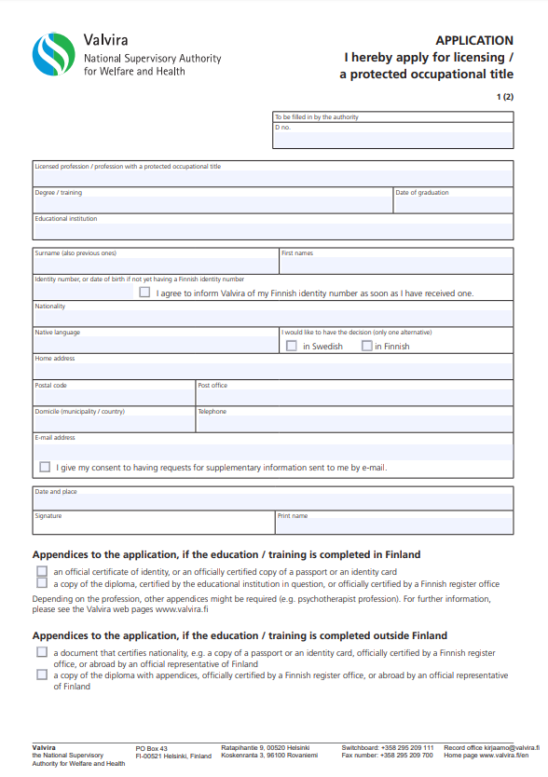

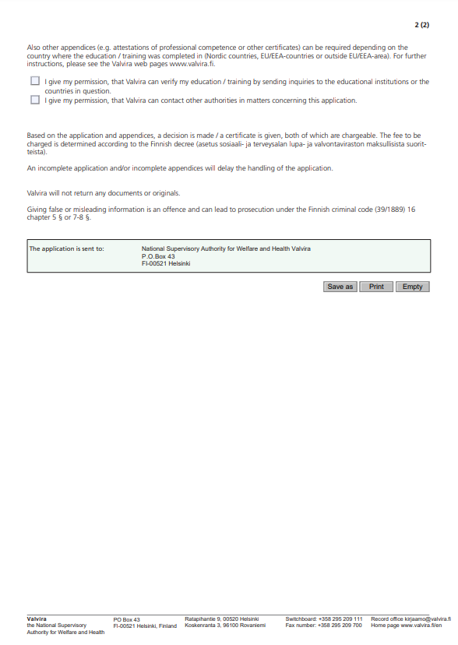

## High-level mappingTop of the form

Figure 2 – Example of a public service, top of the form



Starting with the upper part of the form, we can quickly identify the name of the public organisation, the title of the public service and the related action undertaken here via the form. If we add to this the descriptions provided directly on the Web page of the service, we obtain the following elements[12]:

Figure 3 – Elements mapped for the top of the form



The public service “Protected occupational title” *has a competent authority*, named “National Supervisory Authority for Welfare and Health Valvira”. The most general action required in order to *deliver* this public service is to apply for licensing / a protected occupational title. The maximal estimated time for providing this delivering this action is four months (cfr. Web page) or in the notation used in the model, “P4M” (Period of 4 Months).

However, different choices could be made by the owner of this description while using the SDG model:

* The name of the public organisation could differentiate the official full name (“*National Supervisory Authority for Welfare and Health*”) from the preferred label (“*Valvira*”). In this case, we have decided to use only one name.
* We did not find the publication date and last modified date of the public service description. As a consequence, we decided to leave those elements empty (in grey).
* The processing time differs from the target processing time. The former is an official period of time while the later is an estimated period of time. We understood in this case that the period given on the website is estimated based on the experience of Valvira’s employees.
* There was no specific identifier mentioned in the form or the Web page of Valvira for uniquely identifying the public service. Therefore, we decided to use the URL from the Web page of this service. We did not ask Valvira whether this URL was persistent nor used in practice as identifier. Ideally, public administrations should use persistent identifiers (or persistent URIs).
* In the visual above, only one action is described, covering the whole period estimated for delivering the public service. This can be done differently and we encourage public administrations to use this element to its optimal potential. We could for instance imagine that going through this service requires multiple actions from the requestor and Valvira such as:
  + [Requestor] Filling in the form and collecting the evidence/appendices,
  + [Requestor] Sending the form completed and its appendices,
  + [Valvira] Verifying if the appendices are issued by authoritative sources,
  + [Valvira] Contacting the sources to attest the validity of the information or getting more information,
  + [Valvira] Decide upon the recognition of the professional qualifications,
  + [Valvira] Notify the requestor of the output of the service.
  + …

Each action which is part of this sequence could be described separately with an estimated time or an official processing time. The administration describing this service could also decide to insert an additional element for easily selecting whether the action should be conducted by the requestor or a public administration.

## Body of the form (1)

Figure 4 – Example of a public service, body of the form

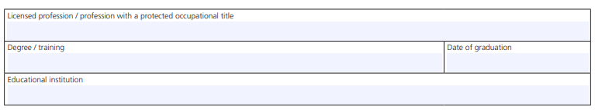

This part of the form asks the requestor to clearly identify the title he or she would like to protect or obtain a licence for. Depending on the answer provided, the requirements and appendices can differ. From a modelling perspective, it means that we should be able to link the specific licensed profession requested with detailed requirements. Let’s assume for instance that the licensed profession required is “general doctor/practitioner”. This profession would require specific criteria such as:

* A Masters Degree in Medicine is needed
* A certificate of a licence to practice your profession is required (cfr Web page)

Each criterion requirement will need to be confirmed with evidence. In our case, the “degree” is the name of the evidence, with the educational institute and the “date of graduation” as specific elements of this evidence. This is illustrated in Figure 5. We will come back to the provision of evidence in section 2.4.

Figure 5 – Elements mapped for the body of the form (1st part)



## Body of the form (2)

The second half of the body mainly asks the person to provide personal information before asking for his or her consent and signature of the document. Within the SDG model, we focus only for now on the personal information even though the elements to be described and how they are described is entirely left to the appreciation of the responsible public administration.

Figure 6 – Example of a public service, body of the form (2)

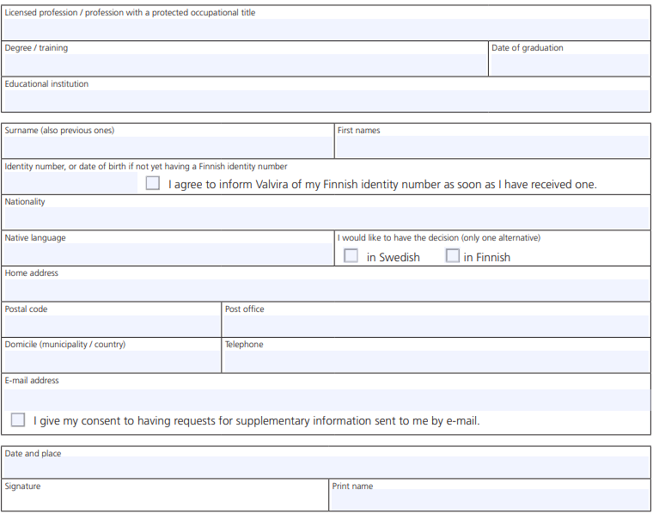

In our example, we took the option of a Finnish citizen applying for this service. However, as indicated in the form, if the person does not possess a Finnish identity number, a date of birth will be required instead. The SDG regulation also requires to indicate whether the service is entitled to business, non-citizens residing in the EU or citizens. This is the reason why a boolean value is used to identify the user of the service.

Figure 7 – Elements mapped for the body of the form (2nd part)



## Evidence

Diving deeper into the evidence required, we observe two types of evidence requested independently from the citizenship as shown in Figure 8:

* The proof of identity
* A copy of the diploma

Figure 8 – Example of a public service, evidence

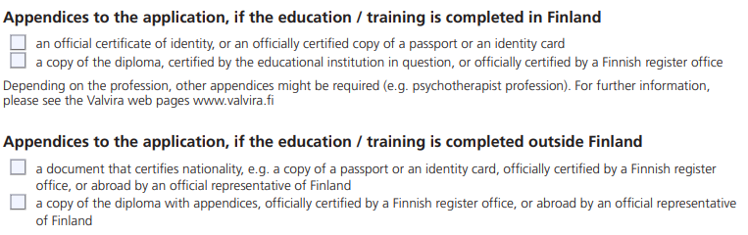

When mapping this to the model, each initial criterion requirement asking for an evidence will also specify a format in which the evidence must be provided. Within the model, the format will be documented under a specific element named “Concept”. This element regroups all classifications used, such as the formats in which a document or evidence must be provided.

In the Figure 9, we give two concrete examples for proving the identity and providing a copy of a diploma. The same mechanism can be applied to the second criterion requirement described before (“A certificate of a licence to practice your profession is required”).

Please also note that a classification could be used for detailing the type of evidence. This classification was not used in this example and is consequently shown below in grey.

Figure 9 – Example of a public service, evidence



## End of the form

The end of the form gives some additional information about the fee that can be charged, the postal address to which a physical signed copy of the form can be sent or about the decision process in general.

Figure 10 – Example of a public service, end of the form

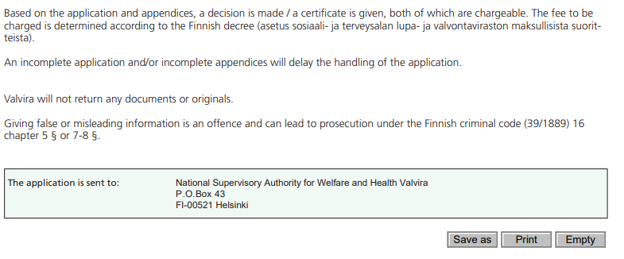

When mapping those additional information to the model, we obtain the Figure 11 where:

* Two extra actions are identified: the action of sending the application form and its appendices and the action of taking a decision whether the requestor could receive a licence or not.
* In our example, we decided to propose a cost which could be charged for receiving this service. This makes use of the element “Cost” described in the model. This element can also use a classification for the currency used for this cost.
* Once the decision is taken, an output can be produced to deliver (or not) the licence. Note that the notification itself could also be modelled as a specific action following the decision.
* The postal address to which the requestor can send the application form. This is captured by the contact point identified for Valvira for one communication channel (in this case “postal”). We could imagine that multiple channels are proposed for providing this form or even that some channels have an entire list of recognized contact points. Having both channel and contact point elements distinct enables this flexibility.
* The form refers to the Finnish criminal code and to the fact that giving false or misleading information is an offence and can lead to prosecution. This is not directly modelled in the SDG model we are proposing but could easily be added following for example the elements used in CPSV-AP: the legal resources and the rules followed by the service.

Figure 11 – Example of a public service, end of the form



## Contact details

Figure 12 – Example of a public service, contact details



The different contact details provided at the bottom of the form can directly translated in elements in the SDG model. To the contact details, we can add the languages specified in the Web page in which the service is provided: English, Finnish and Swedish.

Figure 13 – Mapping of the contact details



## Tangible results of structuring the information about this public service

Throughout this example, we have seen how existing information from a public service currently used can be mapped and structured according to the SDG metadata model. If there is definitely a need to understand the definitions and relations between the elements, this example showed how flexible this model can be. Additional elements were added when needed, no consequent adaptations to the values were made to be able to structure the information. However, by looking at the same elements in a similar way, public administrations create bridges between each other for the information to flow easily and with high quality. It avoids for example that a country creates one classification for the type of channel and another country start using another one.

The core model that we are presenting in the next chapter represents the elements with which every public administration should start in order to share the right information for the repository of links. On top of this core, we have added other elements. All elements are coming from the regulation or are required in order to make correct links between concepts coming from the regulation.

Public administrations have more and more access to an enormous amount of information. Structuring that information is the first (big) step to create benefits for citizens, businesses and public administrations.

# SDG Metadata Model: classes and properties

The specification of the Core Public Service Vocabulary Application Profile is represented in a UML class diagram. Figure 14 shows the full profile which includes:

* The classes and properties that define the service itself: the necessary inputs, possible outputs, the responsible public authority and the events that trigger service use;
* The classes and properties that describe the context in which the service is offered. This includes relevant legislation and rules of operation for the service; and
* The interface between the service and its users: how and when it can be accessed.

Figure 14 - Graphical representation of the relationships between the classes and properties of the proposed SDG Data Model



Figure 15 - Graphical representation of the relationships between the classes and properties of the proposed Core SDG Data Model



## Distinction between the Core and the Extended SDG Data Model

The European Commission has defined a distinction between a Core SDG Data Model and an Extended SDG Data Model. The elements in the Core Model are necessary to be used for the repository of links and by structuring the elements following this Core SDG Data Model, Member States use an efficient tool to exchange data with the repository.

However, by December 2020, when a part of the SDGR is applicable, the Member States will need to share a lot of information (specified in the SDGR) on their online portals. Using the Extended SDG Data Model, Member States could structure their data and publish it on their national website while being compliant with the SDGR. At the moment, most of the mandatory data elements of the SDGR are present in the model, but some data elements were not included because of ongoing discussions by other actions (e.g. feedback data elements).

In the following subsections, all proposed classes and properties are listed.

## The Public Service Class

|  |  |  |
| --- | --- | --- |
| From Data Model | Core / Extended | Reasoning Core / Extended |
| CPSV-AP | Core | The concept of public service is at the core of the entire model. In combination with the new class Action, public administrations should be able to cover both the administration’s and the end-users’ perspectives. |

This class represents the Public Service itself, as it is described in a public service catalogue. A Public Service is a mandatory or discretionary set of activities performed, or able to be performed, by or on behalf of a public organisation, publicly funded and arise from public policy. Services may be for the benefit of an individual, a business, or other public authority, or groups of any of these. A service exists whether it is used or not, and the term 'benefit' may apply in the sense of enabling the fulfilment of an obligation. As defined in the revised version of the European Interoperability Framework[13], a European public service comprises any service provided by public administrations in Europe, or by other organisations on their behalf, to businesses, citizens or others public administrations.

|  |  |
| --- | --- |
| Class name | URI |
| Public Service | cpsv:PublicService |

The following subsections define the properties of the Public Service class.

### Identifier

This property represents a formally-issued Identifier for the Public Service.

|  |  |  |  |
| --- | --- | --- | --- |
| Property | URI | Range | Cardinality |
| identifier | dct:identifier | Text[14] | 1..1 |

### Name

This property represents the official Name of the Public Service.

|  |  |  |  |
| --- | --- | --- | --- |
| Property | URI | Range | Cardinality |
| name | dct:title | Text | 1..1 |

### Description

This property represents a free text Description of the Public Service. The description is likely to be the text that potential users of the Public Service see in any public service catalogue. Public administrations are encouraged to include a reasonable level of detail in the description, for instance including basic eligibility requirements for the particular Public Service and contact information.

|  |  |  |  |
| --- | --- | --- | --- |
| Property | URI | Range | Cardinality |
| description | dct:description | Text | 1..1 |

### Publication Date

This property contains the date of formal issuance (e.g. publication) of the Public Service.

|  |  |  |  |
| --- | --- | --- | --- |
| Property | URI | Range | Cardinality |
| publicationDate | dct:issued | xsd:date OR  xsd:dateTime | 0..1 |

### Update/Modification Date

This property contains the most recent date on which the Public Service was modified.

|  |  |  |  |
| --- | --- | --- | --- |
| Property | URI | Range | Cardinality |
| update/modificationDate | dct:modified | xsd:date OR  xsd:dateTime | 0..1 |

### Thematic Area

This property represents the Thematic Area of a Public Service as described in a controlled vocabulary (or classification), for instance social protection, health, recreation, culture and religion, family, traveling economic affairs, tax, staff, environment... The classification proposed for thematic area is available for your review from the spreadsheet on Github.

Each public service can have zero to many thematic areas defined.

|  |  |  |  |
| --- | --- | --- | --- |
| Property | URI | Range | Cardinality |
| Thematic area | cv:thematicArea | Concept | 0..n |

### Language

This property represents the language(s) in which the Public Service is available. This could be one language or multiple languages, for instance in countries with more than one official language. The possible values for this property are described in a controlled vocabulary.

|  |  |  |  |
| --- | --- | --- | --- |
| Property | URI | Range | Cardinality |
| language | dct:language | dct:LinguisticSystem | 0..n |

### Is Grouped By

This property links the Public Service to the Event class. Several Public Services may be associated with a particular Event and, likewise, the same Public Service may be associated with several different Events.

|  |  |  |  |
| --- | --- | --- | --- |
| Property | URI | Range | Cardinality |
| isGroupedBy | cv:isGroupedBy | Event | 0..n |

### Requires

One Public Service may require, or in some way make use of, the output of one or several other Public Services. In this case, for a Public Service to be executed, another Public Service must be executed beforehand. The nature of the requirement will be described in the associated Rule or Evidence.

|  |  |  |  |
| --- | --- | --- | --- |
| Property | URI | Range | Cardinality |
| requires | dct:requires | Public Service | 0..n |

### Related

This property represents a Public Service related to the particular instance of the Public Service class.

|  |  |  |  |
| --- | --- | --- | --- |
| Property | URI | Range | Cardinality |
| related | dct:relation | Public Service | 0..n |

### Has Criterion

Links a Public Service to a class that describes the criteria for needing or using the service, such as residency in a given location, being over a certain age etc. The Criterion class is defined in the Core Criterion and Core Evidence Vocabulary[15].

|  |  |  |  |
| --- | --- | --- | --- |
| Property | URI | Range | Cardinality |
| hasCriterion | cv:hasCriterion | Criterion Requirement | 0..n |

### Has Competent Authority

This property links a Public Service to a Public Organization, which is the responsible Agent for the delivery of the Public Service. Whether the particular Public Organization provides the public service directly or outsources it is not relevant. The Public Organization that is the Competent Authority of the service is the one that is ultimately responsible for managing and providing the public service.

The term Competent Authority is defined in the Services Directive (2006/123/EC) in the following way:

“*Any body or authority which has a supervisory or regulatory role in a Member State in relation to service activities, including, in particular, administrative authorities, including courts acting as such, professional bodies, and those professional associations or other professional organisations which, in the exercise of their legal autonomy, regulate in a collective manner access to service activities or the exercise thereof*”.

|  |  |  |  |
| --- | --- | --- | --- |
| Property | URI | Range | Cardinality |
| hasCompetentAuthority | cv:hasCompetentAuthority | Public Organisation | 1..1 |

### Has Input

The Has Input property links a Public Service to one or more instances of the Evidence class (see section 3.9). A specific Public Service may require the presence of certain pieces of Evidence in order to be delivered. If the evidence required to make use of a service varies according to the channel through which it is accessed, then Has Input should be at the level of the Channel (section 3.12.2).

|  |  |  |  |
| --- | --- | --- | --- |
| Property | URI | Range | Cardinality |
| hasInput | cpsv:hasInput | Evidence | 0..n |

### Produces

The Produces property links a Public Service to one or more instances of the Output class (see section 3.10), describing the actual result of executing a given Public Service. Outputs can be any resource, for instance a document, artefact or anything else being produced as a result of executing the Public Service.

|  |  |  |  |
| --- | --- | --- | --- |
| Property | URI | Range | Cardinality |
| produces | cpsv:produces | Output | 0..n |

### Spatial

A Public Service is likely to be available only within a given area, typically the area covered by a particular public authority. The possible values for this property are described in a controlled vocabulary.

|  |  |  |  |
| --- | --- | --- | --- |
| Property | URI | Range | Cardinality |
| spatial | dct:spatial | Location | 0..n |

### Has Contact Point

A contact point for the service is almost always helpful. The value of this property, the contact information itself, should be provided using schema:ContactPoint. Note that the contact information should be relevant to the Public Service which may not be the same as contact information for the Competent Authority or any Participant.

|  |  |  |  |
| --- | --- | --- | --- |
| Property | URI | Range | Cardinality |
| hasContactPoint | cv:hasContactPoint | Contact Point | 0..n |

### Has Channel

This property links the Public Service to any Channel through which an Agent provides, uses or otherwise interacts with the Public Service, such as an online service, phone number or office. See section 3.12.

|  |  |  |  |
| --- | --- | --- | --- |
| Property | URI | Range | Cardinality |
| hasChannel | cv:hasChannel | Channel | 0..n |

### Has Cost

The Has Cost property links a Public Service to one or more instances of the Cost class (see section 3.11). It indicates the costs related to the execution of a Public Service for the citizen or business related to the execution of the particular Public Service.

|  |  |  |  |
| --- | --- | --- | --- |
| Property | URI | Range | Cardinality |
| hasCost | cv:hasCost | Cost | 0..n |

### Is Described At

The Is Described At property links a Public Service to the Public Service Dataset(s) (see 3.7) in which it is being described (see section 3.7).

|  |  |  |  |
| --- | --- | --- | --- |
| Property | URI | Range | Cardinality |
| isDescribedAt | cv:isDescribedAt | Public Service Dataset | 0..n |

### Is Classified By

The Is Classified By property allows to classify the Public Service with any Concept (section 3.22). It is a generic property which can be further specialised to make the classification explicit, for instance for classifying public services according to different levels of digitisation, type of audience …

|  |  |  |  |
| --- | --- | --- | --- |
| Property | URI | Range | Cardinality |
| isClassifiedBy | cv:isClassifiedBy | Concept | 0..n |

## The Action Class

|  |  |  |
| --- | --- | --- |
| From Data Model | Core / Extended | Reasoning Core / Extended |
| - | Extended | This class is an important part of the SDGR as it details the steps of a procedure. This reconciles the procedure and the service perspectives into one model. This is part of the extended model as the priority of the model now lies in providing the basic information of a public service in the repository of links. |

This class represents the different actions that, taken together, deliver the Public Service itself.

* E.g. [a EU citizen] requesting a birth certificate
* E.g. [a public organisation] providing the birth certificate

### Name

This property represents the name of the action.

|  |  |  |  |
| --- | --- | --- | --- |
| Property | URI | Range | Cardinality |
| name | dct:title | Text | 1..1 |

### Description

This property represents the description of a granular action.

|  |  |  |  |
| --- | --- | --- | --- |
| Property | URI | Range | Cardinality |
| name | dct:title | Text | 1..1 |

### Target processing time

This property represents the estimated period of time required to conduct the action:

* E.g. a form needs to be filled in by a user within 100 days.
* E.g. a public administration needs to provide a document within two weeks.

It uses the same syntax than processingTime (described below)?

|  |  |  |  |
| --- | --- | --- | --- |
| Property | URI | Range | Cardinality |
| targetProcessingTime | cv:processingTime | Duration | 0..1 |

### Processing time

The value of this property is the official time needed for executing a Public Service. The information might be fixed in certain cases by law. The actual information is provided using the ISO8601 syntax for durations. Some examples are provided below:

|  |  |
| --- | --- |
| Duration | Syntax |
| 5 years | P5Y |
| 1 month | P1M |
| 3 days | P3D |
| 2 days 4 hours | P2DT4H |

Durations begin with an uppercase P followed by the number and the relevant designator, formally: P[n]Y[n]M[n]DT[n]H[n]M[n]S, where Y is for years, M for months etc. Note that days and times are separated by an uppercase T which also disambiguates M as meaning month (P2M means 2 months) or minute (PT2M means 2 minutes). Durations may also be defined as a number of weeks so P4W means 4 weeks. A full explanation is provided in the Wikipedia page[16] that references the official ISO standard[17].

This approach is consistent with both schema.org and the W3C OWL Time Ontology.

|  |  |  |  |
| --- | --- | --- | --- |
| Property | URI | Range | Cardinality |
| processingTime | cv:processingTime | Duration | 0..1 |

## The Event Class

|  |  |  |
| --- | --- | --- |
| From Data Model | Core / Extended | Reasoning Core / Extended |
| CPSV-AP | Extended | We did not put the emphasis of this model on the class Event. However, considering the importance to have a common approach for grouping and finding public services, it is important that the class remains available for any public administration who wuld like to use it. |

This class represents an event that can be of any type that triggers, makes use of, or in some way is related to, a Public Service. It is not expected to be used directly, rather, one or other of its subclasses should be used. The properties of the class are, of course, inherited by those subclasses.

The Event class is used as a hook either to a single related Public Service, such as diagnosis of illness being related to application for sickness benefit; or to a group of Public Services, such as all those related to the establishment of a new business (see section 3.2.8).

|  |  |
| --- | --- |
| Class name | URI |
| Event | cv:Event |

### Type

The type property links an Event to a controlled vocabulary of event types and it is the nature of those controlled vocabularies that is the major difference between a business event, such as creating the business in the first place and a life event, such as the birth of a child.

|  |  |  |  |
| --- | --- | --- | --- |
| Property | URI | Range | Cardinality |
| type | dct:type | Concept | 0..n |

## The Business Event Class

|  |  |  |
| --- | --- | --- |
| From Data Model | Core / Extended | Reasoning Core / Extended |
| CPSV-AP | Extended | Not a priority at this time. |

This class represents a Business Event, which specialises Event. A Business Event is a specific situation or event in the lifecycle of a business that fulfils one or more needs or (legal) obligations of that business at this specific point in time. A Business Event requires a set of public services to be delivered and consumed in order for the associated business need(s) or obligation(s) to be fulfilled. Business Events are defined within the context of a particular Member State.

In other words, a Business Event groups together a number of public services that need to be delivered for completing that particular event.

|  |  |
| --- | --- |
| Class name | URI |
| Business Event | cv:BusinessEvent |

## The Life Event Class

|  |  |  |
| --- | --- | --- |
| From Data Model | Core / Extended | Reasoning Core / Extended |
| CPSV-AP | Extended | Not a priority at this time. |

The Life Event class represents an important event or situations in a citizen's life where public services may be required. Note the scope: an individual will encounter any number of 'events' in the general sense of the word. In the context of the CPSV-AP, the Life Event class **only** represents an event for which a Public Service is related. For example, a couple becoming engaged is not a CPSV-AP Life Event, getting married is, since only the latter has any relevance to public services. We reuse the same logic for the SDG context.

|  |  |
| --- | --- |
| Class name | URI |
| Life Event | cv:LifeEvent |

## The Public Service Dataset Class

|  |  |  |
| --- | --- | --- |
| From Data Model | Core / Extended | Reasoning Core / Extended |
| DCAT-AP | Extended | Not a priority at this time. |

The Public Service Dataset, is a specialisation of the Dataset class of the Data Catalog Vocabulary (DCAT)[18] and inherits all its properties. The class describes the metadata of where the dataset is being described, for instance on a regional public service portal and/or a national eGovernment portal.

|  |  |
| --- | --- |
| Class name | URI |
| Public Service Dataset | cv:PublicServiceDataset |

### Count Assistance Request

This property refers to the number of requests for assistance and problem-solving services.

### Response time

This property refers to the average response time for different requests for assistance and problem-solving services.

## The Criterion Requirement Class

|  |  |  |
| --- | --- | --- |
| From Data Model | Core / Extended | Reasoning Core / Extended |
| CPSV-AP | Extended | In almost all cases, obtaining the provision of a public service requires to answer first to some requirements. This class specifies the requirements. |

Not all public services are needed or usable by everyone. For example, the visa service operated by European countries is not needed by European citizens but is needed by some citizens from elsewhere, or public services offering unemployment benefits and grants are targeting specific societal groups. The CPSV reuses the Core Criterion and Core Evidence Vocabulary[19] for this class. The CCCEV provides more details but the Criterion Requirement class has three mandatory properties.

|  |  |
| --- | --- |
| Class name | URI |
| Criterion Requirement | cv:CriterionRequirement |

## The Evidence Class

|  |  |  |
| --- | --- | --- |
| From Data Model | Core / Extended | Reasoning Core / Extended |
| CPSV-AP | Extended | For each requirement defined, one or more evidence must be provided to the relevant authority. |

The Evidence class is defined in the Core Criterion and Core Evidence vocabulary (CCCEV) as any resource that can document or support a criterion response. It contains information that proves that a criterion requirement exists or is true, in particular evidences are used to prove that a specific criterion is met.

Although the wording of the definition is different, the semantics are an exact match for CPSV's Input class which it replaces.

Evidence can be any resource - document, artefact – anything needed for executing the Public Service. In the context of Public Services, Evidence is usually administrative documents or completed application forms. A specific Public Service may require the presence of certain Evidence or combinations of Evidence in order to be delivered.

|  |  |
| --- | --- |
| Class name | URI |
| Evidence | cv:Evidence |

### Type

This property represents the type of Evidence which could be described in a controlled vocabulary.

|  |  |  |  |
| --- | --- | --- | --- |
| Property | URI | Range | Cardinality |
| type | dct:type | Concept | 0..1 |

## The Output Class

|  |  |  |
| --- | --- | --- |
| From Data Model | Core / Extended | Reasoning Core / Extended |
| CPSV-AP | Extended | Not a priority at this time. |

Outputs can be any resource - document, artefact – anything produced by the Public Service. In the context of a Public Service, the output provides an official document or other artefact of the Competent Authority (Public Organization) that permits/authorises/entitles an Agent to (do) something.

|  |  |
| --- | --- |
| Class name | URI |
| Output | cv:Output |

### Type

This property represents the type of Output as defined in a controlled vocabulary.

|  |  |  |  |
| --- | --- | --- | --- |
| Property | URI | Range | Cardinality |
| type | dct:type | Concept | 0..n |

## The Cost Class

|  |  |  |
| --- | --- | --- |
| From Data Model | Core / Extended | Reasoning Core / Extended |
| CPSV-AP | Extended | Not a priority at this time. |

The Cost class represents any costs related to the execution of a Public Service that the Agent consuming it needs to pay.

|  |  |
| --- | --- |
| Class name | URI |
| Cost | cv:Cost |

### Value

This property represents a numeric value indicating the amount of the Cost.

|  |  |  |  |
| --- | --- | --- | --- |
| Property | URI | Range | Cardinality |
| value | cv:value | Number | 0..1 |

### Currency

This property represents the currency in which the Cost needs to be paid and the value of the Cost is expressed. The possible values for this property are described in a controlled vocabulary.

|  |  |  |  |
| --- | --- | --- | --- |
| Property | URI | Range | Cardinality |
| currency | cv:currency | Concept | 0..1 |

## The Channel Class

|  |  |  |
| --- | --- | --- |
| From Data Model | Core / Extended | Reasoning Core / Extended |
| CPSV-AP | Core | Necessary class as it defines the type of the channel, such as the web page. This information is needed to be defined in the Repository of Links. |

The Channel class represents the medium through which an Agent provides, uses or interacts in another way with a Public Service. Typical examples include online services, phone, walk-in centres etc.

|  |  |
| --- | --- |
| Class name | URI |
| Channel | cv:Channel |

### Type

This property represents the type of Channel as defined in a controlled vocabulary.

|  |  |  |  |
| --- | --- | --- | --- |
| Property | URI | Range | Cardinality |
| type | dct:type | Concept | 0..1 |

### Has contact point

In the majority of cases, the evidence required to use a Public Service will be independent of the channel through which the service is accessed. The Has Input property should normally be used to link a Public Service directly to one or more pieces of Evidence (see section 3.9). However, where the type of Evidence required varies according to the channel used to access the Public Service, then the Has Input property may be used at the Channel level. For example, a digital signature may be required for an online channel, whereas a physical signature may be required for a face to face service provision.

|  |  |  |  |
| --- | --- | --- | --- |
| Property | URI | Range | Cardinality |
| hasInput | cpsv:hasInput | Evidence | 0..n |

### Language

This property represents the language(s) of the channel in which information related to a Public Service is available. This could be one language or multiple languages, for instance in countries with more than one official language. The possible values for this property are described in a controlled vocabulary.

|  |  |  |  |
| --- | --- | --- | --- |
| Property | URI | Range | Cardinality |
| language | dct:language | dct:LinguisticSystem | 0..n |

## The Web Page Class

|  |  |  |
| --- | --- | --- |
| From Data Model | Core / Extended | Reasoning Core / Extended |
| CPSV-AP | Core | Necessary information for the Repository of Links. Key information to refer users on the SDG to the relevant web page. |

This class represents a Web Page, which specialises Channel. A Web Page is a specific page online that consists of information related to a public service.

|  |  |
| --- | --- |
| Class name | URI |
| Web Page | schema:OpeningHoursSpecification |

### URL

This property refers to the URL of a web page.

|  |  |  |  |
| --- | --- | --- | --- |
| Property | URI | Range | Cardinality |
| URL | schema:url | URL | 1..1 |

## The Agent Class

|  |  |  |
| --- | --- | --- |
| From Data Model | Core / Extended | Reasoning Core / Extended |
| CPV | Extended | Not a priority at this time. |

The Agent class is any resource that acts or has the power to act. This includes people, organisations and groups. The Public Organization class, defined in the Core Public Organisation Vocabulary, is a notable sub class of Agent.

|  |  |
| --- | --- |
| Class name | URI |
| Agent | dct:Agent |

### Name

This property represents the Name of the Agent.

|  |  |  |  |
| --- | --- | --- | --- |
| Property | URI | Range | Cardinality |
| name | dct:title | Text | 1..1 |

## The Public Organisation Class

|  |  |  |
| --- | --- | --- |
| From Data Model | Core / Extended | Reasoning Core / Extended |
| CPOV | Core | This information is needed to know what organisation is responsible for a specific public service. Knowing this, users can get referred to the responsible public organisation. |

The SDG metadata model reuses the Core Public Organisation Vocabulary[20] that defines the concept of a Public Organization and associated properties and relationships. It is largely based on the W3C Organization Ontology[21].

|  |  |
| --- | --- |
| Class name | URI |
| Public Organisation | cv:PublicOrganisation |

### Preferred label

This property represents the preferred label of the Public Organization.

|  |  |  |  |
| --- | --- | --- | --- |
| Property | URI | Range | Cardinality |
| preferredLabel | skos:prefLabel | Text | 1..1 |

## Business

|  |  |  |
| --- | --- | --- |
| From Data Model | Core / Extended | Reasoning Core / Extended |
| CPSV-AP |  | This class is a key concept to classify a public service in the SDGR. In this case, we choose not to use a classification, because in the future, properties could be added to the concept. |

This is the key class for the Business Core Vocabulary (called ‘Legal Entity) and represents a business that is legally registered. A Legal Entity is able to trade, is legally liable for its actions, accounts, tax affairs etc.

This makes legal entities distinct from the concept of organisations, groups or sole traders. Many organisations exist that are not legal entities yet to the outside world they have staff, hierarchies, locations etc. Other organisations exist that are an umbrella for several legal entities (universities are often good examples of this). This vocabulary is concerned solely with registered legal entities and does not attempt to cover all possible trading bodies.

Business is a sub class of the more general 'Agent' class that does encompass organisations, natural persons, groups etc. - i.e. an Agent is any entity that is able to carry out actions.

## Non-citizen residing in the EU

|  |  |  |
| --- | --- | --- |
| From Data Model | Core / Extended | Reasoning Core / Extended |
|  | Core | This class is a key concept to classify a public service in the SDGR. In this case, we choose not to use a classification, because in the future, properties could be added to the concept. |

This class represents a natural person residing in a Member State, excluding citizens. Non-citizen residing in the EU is a sub class of the Person class.

## Citizen

|  |  |  |
| --- | --- | --- |
| From Data Model | Core / Extended | Reasoning Core / Extended |
|  | Core | This class is a key concept to classify a public service in the SDGR. In this case, we choose not to use a classification, because in the future, properties could be added to the concept. |

This class represents a European Union Citizen. Citizen is a sub class of the Person class.

## Organisation

|  |  |  |
| --- | --- | --- |
| From Data Model | Core / Extended | Reasoning Core / Extended |
| CPSV-AP | Extended | This class is a key concept to classify a public service in the SDGR. In this case, we choose not to use a classification, because in the future, properties could be added to the concept. |

This class represents an organisation. Organisation is a sub class of the Person class.

## Person

|  |  |  |
| --- | --- | --- |
| From Data Model | Core / Extended | Reasoning Core / Extended |
| CPSV-AP | Extended | This class is a key concept to classify a public service in the SDGR. In this case, we choose not to use a classification, because in the future, properties could be added to the concept. |

This class represents a natural person. Person is a sub class of the Agent class.

## The Contact Point Class

|  |  |  |
| --- | --- | --- |
| From Data Model | Core / Extended | Reasoning Core / Extended |
| CPSV-AP | Extended | Not a priority at this time. |

This class represents the contact information for a Public Service, Channel, Public Organization, etc. It is defined in the Core Public Organisation Vocabulary and is provided as a schema:ContactPoint.

|  |  |
| --- | --- |
| Class name | URI |
| Contact Point | schema:ContactPoint |

### Phone number

This property represents the phone number for the Public Service and Channel.

|  |  |
| --- | --- |
| Property | Range |
| phoneNumber | Text |

### Email address

This property represents the email address for the Public Service and Channel.

|  |  |
| --- | --- |
| Property | Range |
| emailAddress | Text |

## The Concept Class

|  |  |  |
| --- | --- | --- |
| From Data Model | Core / Extended | Reasoning Core / Extended |
| CPSV-AP | Core | A public service should be classified by three classifications: the rights, obligations and rules, the procedures and the assistance and problem-solving services. To make this possible, the concept class is part of the Core model. |

This class represents any concept that can be used for classifying the Public Service and which relates to the Public Service through the property Is Classified By (section 3.2.20). This class is included in the SDG model for classifying the different classes included in the model.

In this context the SDG model reuses the Concept[22] class as defined in the SKOS Simple Knowledge Organization System[23]. For describing the attributes of a Concept (labels, preferred labels, alternative labels, definition …) we refer to SKOS.

|  |  |
| --- | --- |
| Class name | URI |
| Concept | skos:Concept |

### SDG type

This property represents the SDG type of service described. It is an overarching categorisation of more granular and specific classifications such as information areas, procedures, or Assistance and problem solving services. Depending on the classification, the SDGR requires different levels of details to be provided. The possible values for this SDG type property are: Information Area, SDG Procedure, Assistance and problem solving service.

|  |  |  |  |
| --- | --- | --- | --- |
| Property | URI | Range | Cardinality |
| SDG Type | To be defined | Concept | 1..n |

# Recommended Controlled Vocabularies

In order to facilitate the exchange of information on Public Services grouped into business events or life events, controlled vocabularies are intended to harmonise the possible values for certain properties. This improves the interoperability of the descriptions and eases the integration of information coming from different sources. Public Organisations can map the values of the controlled vocabularies they use for describing Public Services in their MS, to the specific values of the controlled vocabularies suggested below.

It is important to mention that the recommended controlled vocabularies are not mandatory. Therefore, other controlled vocabularies which are more suitable or tailored to the national context may be used. They can also be extended by the MSs in order to meet their specific needs. In particular, this can be useful for recommended controlled vocabularies of which only high-level values have been defined. For example, for the property “Thematic Area” of the class “Business Event”, a MS can extend this particular controlled vocabulary by adding additional events or providing additional levels of granularity.

The proposed recommended vocabularies of the core and extended SDG Data model, including the reasoning behind this distinction, can be found in the attached Excel sheet – SDG Classifications.

# Namespaces and Prefixes

This specification uses the following prefixes and namespaces.

Table 1: Namespaces and Prefixes

|  |  |
| --- | --- |
| Prefix | Namespace |
| cv | http://data.europa.eu/m8g/ |
| cpsv | http://purl.org/vocab/cpsv# |
| adms | http://www.w3.org/ns/adms# |
| eli | http://data.europa.eu/eli/ontology# |
| dct | http://purl.org/dc/terms/ |
| dcat | http://www.w3.org/ns/dcat# |
| skos | http://www.w3.org/2004/02/skos/core# |
| schema | https://schema.org/ |
| locn | http://www.w3.org/ns/locn# |
| foaf | http://xmlns.com/foaf/0.1/ |

1. Key Concepts used throughout this document

The working terminology in the table below was defined for the original CPSV-AP in the context of the work of ISA Action 1.3 based on an analysis of existing work and related studies.

Table 2: Definition of key concepts

|  |  |
| --- | --- |
| Term | Definition |
| Administrative formality | A Public Service that is mandatory in the context of given Business Event. |
| Public Service | A public service is the capacity to carry out a procedure and exists whether it is used or not. It is a set of deeds and acts performed by or on behalf of a public administration for the benefit of, or mandatory to be executed by a citizen, a business or another public administration. |
| Business Lifecycle | The Business Lifecycle is the lifecycle of a business from its creation until its termination. It is comprised of different situations or events a business can be in during its existence. These situations or events are called business events. |
| Business Event[24] | A specific situation or event in the lifecycle of a business, which relates to one or more needs or obligations of that business at this specific point in time. A Business Event requires a set of public services to be delivered in order for the associated business need(s) or obligation(s) to be fulfilled. Business Events are defined within the context of a particular Member State. |
| Key Business Event | A generic situation or event in the lifecycle of a business, independent from a specific Member State’s legal context or the type and the activities of the business, during which any business carries out its business activities and interactions with Government. We identify the following Key Business Events:   1. Starting business:  All public services for local businesses until the business is eligible for operation. Some examples of events that would fall under this Key Business Event are “Starting a company”, “Starting a new activity”, "Applying for licenses, permits and certificates"… 2. Starting cross-border business:  All public services for foreign businesses (branches or temporary service provision) until the business is eligible for operation. Some examples of events that would fall under this Key Business Event are “Registering a company abroad”, “Starting a new branch”… 3. Doing business:  All public services for business operation, growth, expansion, staffing and taxes. Some examples of events that would fall under this Key Business Event are "Financing a business", "Staffing", "Reporting and notifying authorities", "Paying taxes"... 4. Closing business:  All public services related to closing a business. This covers also mergers and acquisitions. The criterion is a change in the registry that causes a termination of operation of a legal entity. Some examples of events that would fall under this Key Business Event are "Closing down a company", "Closing a branch", "Merging you company", "Selling your company", "Bankruptcy"… |
| Public Service Portfolio | The complete set of public services that are managed by a governmental service provider. The portfolio is used to manage the entire lifecycle of all public services, and includes services from all phases of that lifecycle: service pipeline (proposed or in development), service catalogue (live or available for deployment), and retired services. |
| Catalogue of Public Services | A catalogue of public services is a collection of descriptions of active public services that are provided by public administrations at any administrative level (i.e. local, regional, national or pan-European). All public service descriptions published in a catalogue of public services conform to a common data model for representing public services. |
| Competent Authority | Any body or authority which has a supervisory or regulatory role in a Member State in relation to service activities, including, in particular, administrative authorities, including courts acting as such, professional bodies, and those professional associations or other professional organizations which, in the exercise of their legal autonomy, regulate in a collective manner access to service activities or the exercise thereof. |

1. <https://en.wikipedia.org/wiki/Resource_Description_Framework>
2. <https://www.europeandataportal.eu/en/providing-data/how-to-be-harvested-by-us>
3. <https://www.europeandataportal.eu/en/providing-data/goldbook/putting-place-open-data-lifecycle>
4. [Miguel.ALVAREZ-RODRIGUEZ@ec.europa.eu](mailto:Miguel.ALVAREZ-RODRIGUEZ@ec.europa.eu)
5. <https://joinup.ec.europa.eu/solution/core-public-service-vocabulary-application-profile>
6. <https://joinup.ec.europa.eu/solution/dcat-application-profile-data-portals-europe>
7. <https://joinup.ec.europa.eu/solution/e-government-core-vocabularies>
8. <https://github.com/catalogue-of-services-isa/CPSV-AP/labels/SDG%20domain%20model>
9. <https://www.valvira.fi/documents/18508/3651383/Hakemus_toimia_laillistettuna_nimikesuojattuna_terveydenhuollon_ammattihenkilona_en.pdf/1b2dbab4-25bd-9be0-cee0-3c0b6365ac4d>
10. <https://www.valvira.fi/web/en/healthcare/professional_practice_rights/qualified_in_eu_eea_member_state/protected_occupational_titles>
11. This means that not all information provided in the form or Web page will be used.
12. The background colors are not important as part of this example. It only distinguishes elements aligned with CPSV-AP (in blue) from new elements not present in CPSV-AP (yellow).
13. <http://ec.europa.eu/isa/documents/isa_annex_ii_eif_en.pdf>
14. *This property should be a URI if it is modelled in RDF.*
15. <https://joinup.ec.europa.eu/asset/criterion_evidence_cv/description>
16. https://en.wikipedia.org/wiki/ISO_8601#Durations
17. http://www.iso.org/iso/catalogue_detail?csnumber=40874
18. <https://www.w3.org/TR/vocab-dcat/#class-dataset>
19. https://joinup.ec.europa.eu/asset/criterion_evidence_cv/description
20. https://joinup.ec.europa.eu/asset/cpov/asset_release/all
21. <http://www.w3.org/TR/vocab-org/>
22. https://www.w3.org/TR/skos-reference/#concepts
23. https://www.w3.org/TR/skos-reference/
24. Definition has been based on the definition of a life event in «Reference Models for e-Services Integration based on Life-Events by Todorovski et al., 2006 : « A life event is a specific situation or event in the life of a citizen or a life cycle of an organization that requires a set of public services to be performed.»